**DATAFLOW DIAGRAM**

Project Design Phase-II

Data Flow Diagram & User Stories

|  |  |
| --- | --- |
| Date | 03 October 2022 |
| Team ID | PNT2022TMID42037 |
| Project Name | Efficient Water Quality Analysis and Prediction Using Machine Learning |
| Maximum Marks | 4 Marks |

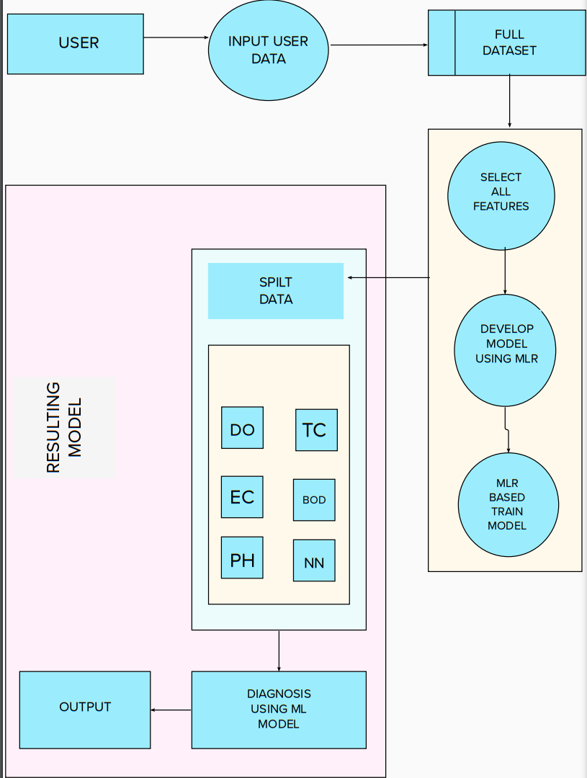

**USER STORIES**

